cuckoo
All Words & Music: © Darren Poyzer . www.poyzer.com . tel 07866 507441
Cuckoo, biding her time
Occasional table, lover of mine
Over dinner and bottle of wine
Cuckoo, left undressed,
As another flies over the cuckoo's nest
In the name of progress
Mother Nature calling, out of the wild
Fears the forest falling, like the death of a child
But these are the days when the motorways come first now
We get from A to B but for you there's no way home No way home
Cuckoo, immaterial girl
Community spirited, heart and soul
Waking up to the stupid world
Cuckoo, so we get in the car
Swap the air that we breathe for a trip to the stars
Blind faith in science, how bizarre
All these fields to roam in, with freedom of choice
A nation of foxes hung up in your closet without a voice
Here comes another excuse for the hunt to quench its thirst now
Makes you so damn sick but you know you're not alone
Cuckoo, she's biding her time, biding her time
In the name of progress In the name of progess Cuckoo ... (to finish)
~ ~ ~
cuckoo
All Words & Music: © Darren Poyzer . www.poyzer.com . tel 07866 507441
Guitar chord shapes used in this song:
(Normal tuning)

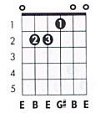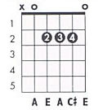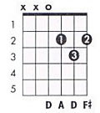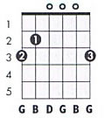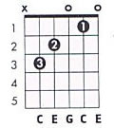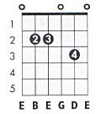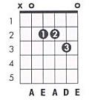

The verse runs E to A repeatedly, then D to G for “Mother Nature calling”.

Then for “These are the days … “ it’s a G to D to C to Em7 to D run, then again for “We get from A to B …” but ending on an A chord / to Asus4, instead of the D.

There’s a lot of E to A in this as on both recordings and live, there’s space for fiddle and guitar riffs to fill the spaces.

~ ~ ~

‘Cuckoo’ was first recorded and featured on the ‘Passion And Conflict’ album and later on the ‘Global’ DVD & CD.

These chords and lyrics compliment the Songbook video at www.poyzer.com

